Nepal College of information technology
Unit test-2010

Program : BE |  | Full Marks : 70
Semester : V |  | Time : 2hrs
Subject : Integrated Digital Electronics |  | .
Attempt all the questions.

 | - Explain in detail, how the circuit shown below works as a logic inverter .Assuming β = 70, V_{BE (on)} = 0.65V, V_{BE (sat)} = 0.75V, V_{CE (sat)} = 0.16V , explain and plot its VTC. and calculate the noise margins for high and low inputs.  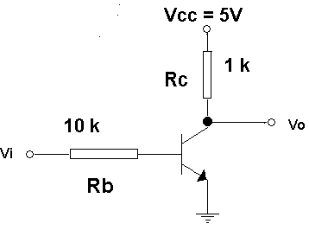  - How does the IIL offer a high packing density? Explain a 3 bit IIL decoder. | 2+5  3+5
 | - Explain and plot the input-output characteristic for the medium power commercial RTL gate at 25 °C, for a fan out of 5. V_{BE (cut in)} = 0.65V, V_{BE (sat)} = 0.75, V_{CE (sat)} = 0.16V, h_{FE} = 50, σ = 0.85 at 25 °C.  - Calculate ∆0 and ∆1 noise margins of the above mentioned RTL gate at temperatures 125 °C and -55 °C without ignoring the temperature dependency of V_{CE (sat)} . | 8
 |  | 7
 | a) Define propagation delay hazard. Explain why the turn-on delay of .....the output transistor in DTL is smaller than the turn-off delay.  b) Stating all the necessary assumptions you make, derive an expression  for the fan out for the IC DTL gate G1 shown below, and explain the  effect of increasing and decreasing p in it.  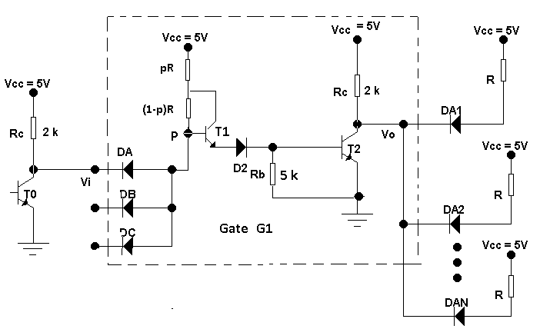 | 2+3
 |  | 7+3
4. | - Answer the following questions, referring the following circuit.  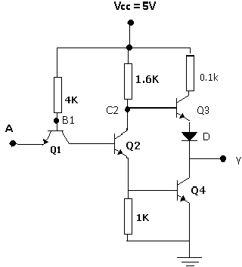  - Explain the operation of the circuit when the input is high.  - What are the functions of the transistors Q2, Q3 and the diode D?  - Calculate the voltages at point B1 and C2 when the input is high , and at point Y when the input is low.  - Explain why a wired-logic connection is not allowed with totem-pole output circuits.  - Draw a circuit diagram for the tri-state TTL gate and explain its operation. (5) | 10
5. | Write short notes on (Any two)  - Charge compensation  - Current hogging in DCTL gates  - High Threshold Logic | 2*5

